Understanding mutual social influence when what people believe fits with their other beliefs

By Bruce Edmonds, Peter Steiglechner, Jan Lorenz, František Kalvas and Marlene C. L. Batzke

**Abstract** Humans tend to accept beliefs that are coherent with their other beliefs and reject those that do not fit with them. As a result of this, different people might arrive at different belief structures and the consequences of this on societal belief patterns are not known. In this chapter we show one way to induce possible ‘coherence structures’ for groups of people from survey data and then set them going, influencing each other, within a computer simulation of individual agents. Of course, people do not perfectly adhere to coherence strategy but are amenable to all sorts of other influences. In the simulation, these other influences are represented as randomness that affects whether to accept or reject beliefs. The simulation shows that the degree to which agents act randomly (rather than based on coherence) is critical to the outcomes. Low levels of randomness (i.e., strong strive for coherence) result in each group converging on more extreme beliefs. With high levels of randomness (i.e., weak striving for coherence) the simulated agents converge on moderate beliefs. It is with some intermediate adherence to coherence that the resulting spread of beliefs looks more like what we observe in the real world—spread out or polarised in some beliefs but converged in others. The approach is illustrated using data from the European Social Survey.

**Keywords**: cognitive coherence, social influence, agent-based simulation, diversity, polarisation, data-driven

Motivation

Cognitive coherence or consistency is the idea that an individual’s beliefs, opinions and attitudes tend to be coherent to each other. So, to give some examples:

* if one likes to drive a car then one might be more likely to think the dangers of climate change are exaggerated,
* if one is against COVID vaccination then one is probably also against other measures, such as the compulsory wearing of masks,
* if one believes that a minimum wage is a good thing, then one also believes that of some kind of universal health insurance/provision.

Thus, by and large, an individual’s beliefs, opinions and attitudes do not contract each other, either in terms of their detailed implications or their broader associations. This goes beyond strict logical consistency—such as beliefs about climate change determining environmental attitudes—but is more related to `emergent’ coherence, e.g. related to questions of identity. Thus, for example, most people do not have some right-wing beliefs and some left-wing ones but tend to be at some point on the left-right political spectrum in a recognisable manner, and beliefs, opinions and attitudes may all cohere with each other in non-obvious ways (DellaPosta et al., 2015). For this reason, we will use the broader term “coherence” rather than “consistency” here, but as we envisage it consistency is a particular and specific form of coherence. In the following, we will use the term belief more broadly to capture opinions, attitudes and beliefs together, although there might be differences in how coherence between these elements could be represented (discussed later).

This need for coherence has been described as a universal motive and a psychological need (Festinger, 1957; Heider, 1946, 1958), or, to put it another way, people seek to increase their coherence (Thagard, 2000). Incoherence between cognitive elements, such as between two beliefs, creates a feeling of dissonance (Festinger, 1957), which has been described as a psychologically uncomfortable state that people tend to avoid or seek to alleviate using a variety of strategies (e.g., by changing their attitudes, Harmon-Jones & Harmon-Jones, 2007).

These tendencies can be particularly powerful in conjunction with those associated with social identity. Our beliefs central to our identity are particularly resistant to change (because they are part of a whole system of such beliefs, all mutually coherent), so these tend to form the coherency context to less fixed beliefs. Hence, for modelling purposes, we try to divide people into groups that share the same relationships between beliefs, which we call their shared “cognitive model”. Individuals with a shared cognitive model do not need to agree on the beliefs; they just need to agree on the coherence of beliefs, such as what set of beliefs constitutes a conservative or a liberal. We derived these groups with distinct cognitive models empirically, as described in the following section. The aim is that all the intensities of belief of individuals in the same group are correlated in the same way.

We also assume that individuals’ beliefs change in order to improve the internal coherence of these beliefs. In this research we focus on two processes for such change: social influence and self-reflection. Humans are inherently social animals, highly influenced by their social surroundings and so may accept the suggested beliefs of others that they interact with. This adds to the beliefs an agent has (or intensifies their degree of belief). At the same time, they possess the “distinctly human” capability to reflect upon their own beliefs in a process that favours discrepancy reduction (Bandura, 2001b) - this may result in the dropping of an existing belief (or reduces their degree of belief towards zero).

The General Approach

In this section we describe the general approach, before illustrating this with a particular implementation in the next section. The key idea here is to initialise the cognitive models in an ABM using data, so that there is not one cognitive model for all agents, but a set of models—one for each subgroup of agents. These agents will not agree on the issues, but they will share the model, i.e. the logic of what constitutes coherence and dissonance. The goal here is to do this in a way that better represents a population of survey respondents. These cognitive models are then used in a simulation to determine how the agents learn, interact, and behave. What is important for us is to explore the way that these agents might interact. This approach involves the following stages.

1. Choose a theoretical framework concerning the relevant cognitive processes of individuals, preferably one which has some empirical support.
2. Find some suitable data about individuals; select from this and prepare it.
3. Use the framework and the data to simultaneously infer:
   1. A partition of the individuals into subsets.
   2. A cognitive model for each sub-set.
4. Implement these subsets and corresponding cognitive models in an ABM.
5. Run the ABM and analyse the results.

This extends the idea of data-driven ABM (e.g. Dean & George 2000, Kennedy & al. 2007, Hassan & al. 2010) where (for example) the state of agents or the environment might be inferred from data, to also specifying aspects of their learning and decision-making processes. Clearly, there are lots of different ways of implementing such a project – we will only demonstrate one here.

The motivation here is (a) to move towards a more data-driven approach to initialising a set of interacting agents and (b) to move away from generic approaches where all agents are endowed with basically the same cognitive model and towards one that is more tailored to reflect some more of the diversity that we observe. We hypothesise that such a move is important in order to better understand how both a group-based convergence of views but also an intra-group divergence of views can develop and co-exist.

An Exemplar of the Approach

In line with the above, we implement two processes of belief change in our simulation model: social influence and self-reflection. Both are assumed to work towards improving an individual’s internal belief coherence. While the desire for coherence is considered universal, how internal belief coherence is defined will depend on two things: (1) the “cognitive model” that is shared with the other individuals in the group (which can be thought of as standing in for all the other beliefs of agents that result in the group organising political beliefs in a similar fashion) and (2) the foreground, explicitly modelled, beliefs they have.

We describe the approach we used in this proof of concept in more detail below, but to summarise our principle choices, they were:

1. The framework we chose was that of “belief coherence”—suggesting that individuals accept their beliefs based upon their coherence with their other beliefs—and “social influence”—suggesting that, besides self-reflection, social interaction can trigger belief change subject to coherence. Within this framework, the particular model of belief coherence we used was that of correlation between different beliefs and their manifestations among a subpopulation.
2. We used the German sample of the 2019 European Social Survey, using the responses to five items in the survey representing political attitudes.
3. To infer the groups + their cognitive models we used Correlational Class Analysis (CCA).
4. The ABM including the different correlation models for sub-groups and the initial belief intensities on each issue was implemented both in NetLogo and Python.
5. The results are described below.

We now describe this in greater detail.

Data Analysis

To empirically derive different cognitive models and the sub-groups that these belong to, we used the German sample of the 2019 European Social Survey (ESS ERIC, 2021). From the survey data we selected five items measuring political beliefs: regarding homosexuals’ rights (*freehms*), support for the European Union (*euftf*), the role of the government in reducing inequality (*gincdif*), immigration (*impcntr*) and political orientation (*lrscale*). For example, the question for the item euftf is: “Now thinking about the European Union, some say European unification should go further. Others say it has already gone too far. Using this card, what number on the scale [from 0 to 10] best describes your position?”. We chose those items that distinctly measured political beliefs (see Table 1 below for more details). We transformed these to a common scale to indicate agreement; towards homosexuals’ rights, support for the EU, governmental efforts to reduce inequality, immigration, and being positioned in the `right’ side of the political spectrum.

We use the German subset of the 9th wave of the ESS survey (ESS ERIC, 2021) collected between 2018 and 2019. There are, in total, 2358 participants. We removed those with any invalid data or “Don’t know” answers leaving a total of 2203 valid participant replies. Note that we inverted the scale for three of the five dimensions: freehms, gincdif, and impcntr, such that a higher score means the participant supported “more EU unification” (euftf), “more freedom for homosexuals” (freehms), “more government measures to reduce income inequality” (gincdif), and “more immigration from poor countries” as well as located themselves “more on the ‘right’ in the political spectrum” (lrscale). Each of the questions have different Likert-type scales, so we rescaled the responses of each item separately to values between -1 to 1 using linear translation, where a value of 1 corresponds to the highest scale possible.

|  |  |  |  |
| --- | --- | --- | --- |
| Key | Topic | Question | Original Scale |
| *euftf* | European Union: European unification go further or gone too far | Question: Now thinking about the European Union, some say European unification should go further. Others say it has already gone too far. Using this card, what number on the scale best describes your position? | 0—10 |
| *freehms* | Gays and lesbians free to live life as they wish | Using this card, please say to what extent you agree or disagree with each of the following statements. Gay men and lesbians should be free to live their own life as they wish | 1—5  inverted |
| *gincdif* | Government should reduce differences in income levels | Using this card, please say to what extent you agree or disagree with each of the following statements. The government should take measures to reduce differences in income levels | 1—5  inverted |
| *lrscale* | Placement on left right scale | In politics people sometimes talk of 'left' and 'right'. Using this card, where would you place yourself on this scale, where 0 means the left and 10 means the right? | 0—10 |
| *impcntr* | Allow many/few immigrants from poorer countries outside Europe | [Now, using this card, to what extent do you think Germany should allow] people from the poorer countries outside Europe [to come and live here]? | 1—4  inverted |

**Table 1.** Selected questions from the ESS 9 questionnaire that define the five belief dimensions.

Deriving Cognitive Models and Group Membership from the Data using Correlational Class Analysis

Correlational Class Analysis (CCA hereafter; Boutyline, 2017) was applied to deduce different cognitive models and corresponding sub-groups from the data. CCA is a methodology for identifying groups of data individuals that share similar correlational schemas. We do not go into the details of the algorithm here (see Newman, 2006, for a detailed description). To broadly summarise, a pair-wise measure of similarity between individuals is determined by the correlation of their belief intensities, and then an algorithm of modularity-maximisation is applied returning a partition of the individuals into a certain number of groups. These groups represent those individuals that we assume perceive similar coherence relations between beliefs. In contrast to standard clustering on their beliefs, they do not necessarily agree on the values. For example, people with entirely right-wing beliefs may interpret coherence very similar to people with entirely left-wing beliefs — they share a subjective `logic’ of belief systems.

There is a single parameter for this process - a significance level that determines which correlations are considered in the analysis, but here we set this parameter to zero, resulting in all correlations being considered and hence got a smaller number of groups (three in this case). These three groups had 562, 601, and 1040 respondents. This, simple case is sufficient to illustrate all of our basic points.

Differences in Cognitive Models of Each Group

In the following, we describe the cognitive models of the three groups from 3-CCA grouping. To illustrate differences between those groups, we also analyse the dominant political parties that members of the groups voted for. The three groups identified are now described.

*Group 1*. The cognitive model of group 1 (n=1040) is defined by associating support of homosexual rights positively with support of immigration and the EU. Supporting homosexual rights is also associated with being left-wing and endorsing governmental action regarding inequality. Group 1 is composed of people that voted disproportionately for the Green Party (and the social democrat party, SPD).

*Group 2*. In the cognitive model of group 2 (n = 601), supporting homosexual rights is related to being positioned on the ‘right’ side of the political spectrum and against governmental action regarding inequality. Supporting governmental action regarding inequality is in turn related to opposition to immigration from poorer countries. Group 2 is composed of people that voted disproportionately for the Conservative Party (with considerable proportions who voted for the right-wing party, AfD, and the liberal party, FDP).

*Group 3*. The cognitive model of group 3 (n = 562) is described by associating the support of homosexual rights with being in favour of governmental action regarding inequality and being against further European unification. Opposition to further European unification is in turn associated with being left-wing and in opposition to immigration from poor countries. Group 3 comprises voters from all parties (with similar proportions as in the overall population) demonstrating a diverse range of political affiliations.

The Simulation

We now present an agent-based model (ABM), which simulates the belief dynamics of a society of individual human beings. The model was implemented in NetLogo (Wilensky, 1999) version 6.3.0 as well as a version in Python version 3.9. Readers less interested in the model may jump to Section “Summary, Initialisation and Experiments”, where we summarise the most important aspects of the model and outline the simulation experiments.

Agent Characteristics

In this simulation we have *N* = 2203 agents, where each agent represents one participant in the survey data, as described above. Agents each have five values, each corresponding to the extent that they agree with [value 1], disagree with [-1] or are indifferent to the five belief dimensions in the survey data. Agents are initialised with the values for these in each of the data points.

Measuring Belief Coherence

[The cognitive model](https://www.codecogs.com/eqnedit.php?latex=%20c%5Ei(x)%20%5C%20%3D%20%5C%20%5Cfrac%7B1%7D%7B2%7D%5Ccdot%20x%5ET%20(R%5Ei%20-%20%5Cmathbb%7BI%7D)%20%5Ccdot%20x%20%3D%20%5C%20r%5Ei_%7B%5Crm%20%5C%7B1%2C2%5C%7D%7D%20%5Ccdot%20x_1%20%5Ccdot%20x_2%20%2B%20r%5Ei%20_%7B%5Crm%20%5C%7B1%2C3%5C%7D%7D%20%5Ccdot%20x_1%20%5Ccdot%20x_3%20%2B%20%5Cldots%20%5C%20%5Cquad%20%20%5C%5C%5C%5C%5C%5C%20%5Cqquad%20%5Cqquad%20%5Ctext%7Bwhere%20%7DR%5Ei%20%3D%20%5Cbegin%7Bpmatrix%7D%201%20%26%20r%5Ei_%7B%5C%7B1%2C2%5C%7D%7D%20%26%20r%5Ei_%7B%5C%7B1%2C3%5C%7D%7D%20%26%20%5Cldots%20%20%5C%5C%5C%5C%20r%5Ei_%7B%5C%7B1%2C2%5C%7D%7D%20%26%201%20%26%20r%5Ei_%7B%5C%7B2%2C3%5C%7D%7D%20%26%20%5Cldots%20%5C%5C%5C%5C%20r%5Ei_%7B%5C%7B1%2C3%5C%7D%7D%20%26%20r%5Ei_%7B%5C%7B2%2C3%5C%7D%7D%20%26%201%20%26%20%5Cldots%20%5C%5C%5C%5C%20%5Cldots%20%26%20%5Cldots%20%26%20%5Cldots%20%26%20%5Cldots%20%5Cend%7Bpmatrix%7D%20.%20" \l "0) of an agent in the simulation is simply the correlation matrix of the survey data inferred from the subset of participants that contains that agent. The sign of each matrix element at position {a, b} indicates whether beliefs *a* and *b* should be correlated (positive sign) or anti-correlated (negative sign) for that. The magnitude ofthe matrix element at *{a, b}* indicates how important this correlation is to the agent’s evaluation of a set of beliefs. If the element is 0 the agent perceives belief items *a* and *b*as fully independent. The idea is that this matrix captures some of the pattern of the belief intensities of the group the agent belongs to.

Given this, the coherence of a set of beliefs, *x*, is *½ · xT · (Ri - I) · x*, where Ri is the 5x5-dimensional correlation matrix held by individual i. Intuitively, this is the extent to which that set is correlated according to the groups correlation matrix. This is quite a simplistic way of calculating belief coherence, but it captures a little bit of the general idea and is sufficient for the illustration of the idea.

Belief Change and the Coherence Cognitive Model

Beliefs change through two processes: social influence and self-reflection. In each time step, each agent engages in social interaction with another agent with some probability. We distribute the agents randomly in a sparse small-world social network (Watts and Strogatz, 1998) and restrict social interactions only to those agents with a direct link between them (which means that the interaction network is independent of group membership).

Each simulation time click, each agent follows these steps:

1. one of the other agents it is linked to is selected at random
2. one of the belief dimensions of that agent is randomly selected
3. the number representing the intensity of the selected belief and the belief dimension is presented to the original agent
4. the original agent then calculates the coherence of its belief set if it adopted this presented belief and compares it with the coherence of its current belief set
5. the belief of the original agent in that dimension moves in the direction of the suggested belief with a certain rate (a parameter), that depends logistically on the coherence difference between currently held and hypothetically held beliefs. This logistic curve is parameterised by a parameter, *k*, so it is sharper with high k and flatter with low k (so k determines the strength of the coherence as compared to noise in accepting and adapting new beliefs)

Besides social interactions, an agent’s belief on a topic *m* can also change through self-reflection. This process also occurs with some probability in each time step after a potential social interaction. Self-reflection follows the same principle as social interaction (steps 2 to 5), but the suggested belief on the focal topic, *m*, is not the belief of a neighbouring agent (as in step 3 above), but a random fluctuation of the agent’s prior belief (drawn from a zero-mean normal distribution and truncated such that the suggested belief remains within the bounds of the belief space, *+1* or *-1*).

Summary, Initialisation and Experiments:

Let us emphasise the most important aspects of our model again: Agents update their beliefs following social and asocial (noisy) influences. The parameter *k* determines how important coherence is to the agents by controlling the amount of determinism/randomness in this belief update process. If agents do not care whether their beliefs are coherent with each other (given their cognitive model), i.e. *k=0*, they decide randomly whether to incorporate social/asocial influences. But if agents care a lot about the coherence of their beliefs, e.g. for *k=100*, they only adapt to social interaction or self-reflection when this adaptation would increase the internal coherence of their set of beliefs, and consequently they reject all influences that do not increase coherence.

The crucial aspect in this study is that agents have particular preferences for which combinations of beliefs they find coherent or incoherent, which is represented by their cognitive model, but different agents may have different cognitive models and thus different perspectives on coherence of a given belief.

We initialise the model as follows:

Each agent represents one of the *n=2203* participants in the German sample for the ESS 9 survey (ESS ERIC, 2021) and we endow each agent with an initial set of beliefs at time *t=0* according to the participant’s answer in the survey.

We also endow each agent with a cognitive model corresponding to its group membership. We compare two experimental setups considering different groupings of agents:

1. No grouping at all, i.e. all agents have the same cognitive model (represented by the correlations calculated from all the belief intensities of all agents. This experiment represents our baseline assumption.
2. The three groups derived using the CCA algorithm as described above. This experiment is our main test scenario.

Here, we illustrate general dynamics of the model. We then show how dividing the agents into groups in the way described makes a difference to the resulting belief intensities for different coherence “strengths” (*k*).

Indicative Exploration of the Dynamics

First, we just give some illustrative outcomes from the simulation to give a flavour of its dynamics, in Fig.2.

**Fig 2.** Some illustrative simulation results. 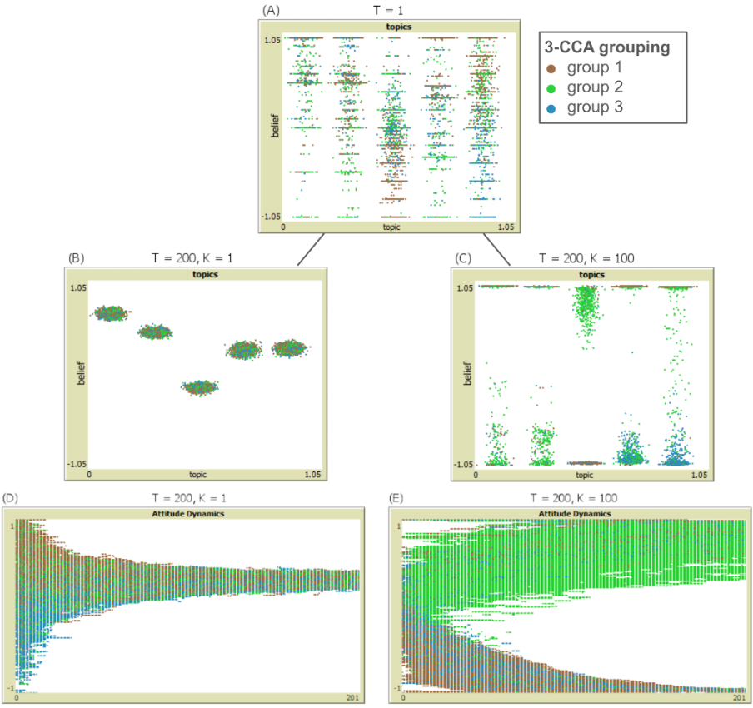

Panel (A) in Fig. 2 shows the agent beliefs on different topics at the start of the simulation, with each dot representing an individual. The colours of the dots indicate which group it is in. The value of the different beliefs for each individual are shown on the y-axis, from 1 (completely agree with it) to -1 (completely disagree). The options available to respondents in the survey, here mapped onto [-1, 1], restricts the initial range of values (which appear as lines in the panel).

In the second row, we show belief distributionsafter 200 simulation time clicks: on the left the result for k=1, the case where there is a lot of randomness involved in belief change (the coherency pressure is low), and on the right the result for k=100, the case where the coherency pressure is high. These illustrate extreme cases, and it is likely that real humans lie somewhere in between. We see in the low coherency case (left) that all belief values for all groups have now clustered around the same values, which is not surprising as randomness in the belief change dominates the differing cognitive models for each group. In the very high coherency case (right), the belief values for agents have shifted to the extremes but differently for different groups.

The bottom two panels in Figure 2 show the dynamics over time for the same two cases for one particular topic. On the left, with low coherency, although each group might start with different beliefs (shown by the distribution along the y-axis) they converge to the same values over time. On the right, with a high coherency pressure, different groups each converge to different final values. That is, there is still convergence within the group, but a divergence between groups.

**Fig 3.** Final distribution of agent beliefs in each group in an example simulation with the three groups, i.e. with experimental setting 2, and *k=100*. The colours denote the five different topics. The belief space, *[-1, 1]*, is binned into four categories (strong disagreement, disagreement, agreement, strong agreement). For instance, group 1 is quite consensual about all topics with a nearly unanimous positive stance on all topics. Group 2 is largely split for most topics, except for its shared support for the EU (*euftf*). Beliefs in group 3 are quite diverse on topics such as immigration (*impcntr*), but nearly unanimous on homosexual rights (*freehms*) or governmental action regarding inequality (*gincdif*). 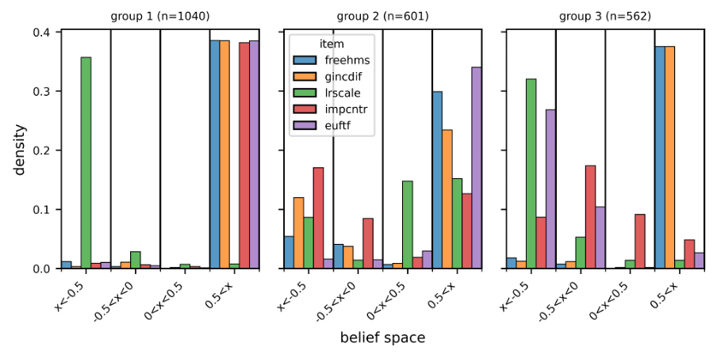

Figure 3 shows the final distribution of beliefs (at *t=200*) among the agents split into the three groups (left, middle and right) in one example simulation with a high importance of coherence, *k*=*100*. The model produces nearly full consensus among the agents in group 1 (left panel). The model, however, also produces within-group diversity on certain topics (e.g. immigration, *impcntr)* among the agents in group 2 and fosters between-group diversity (e.g. on (dis-)approving the EU, *euftf*).

Agents in the simulation tend to move in the direction of maximal coherence, with high k. But this can mean different things. In group 1, for example, the beliefs of nearly all agents converge to the same corner in the belief space that maximises the group’s coherence, *x=(1,1,-1,1,1)*. Finally, the agents remain moderate about some beliefs in certain groups, for example, group 3 has a moderate stance on immigration (*impcntr*). This is plausible since the cognitive model of this group suggests that coherence is largely independent of beliefs about immigration. To what extent within-group and between-group diversity arise depends non-trivially on the grouping and the importance of coherence, *k*.

Impact of Coherence on the Group Beliefs

**Fig 4.** Mean beliefs (and standard deviation) for Experiment 1 (top) without grouping in panels A or the groups from Experiment 2 (bottom) with 3 groups in panels B for each of the five topics (1-5, shown from left to right). Each panel shows the mean and standard deviation of the outcomes of many simulations starting from the same initial conditions, but with varying k (from left to right in each panel). When coherence is not important (low *k*), the agents reach a consensus within and between groups. As coherence becomes more important (high *k*), the mean beliefs (solid lines) of the groups polarise—referred to as between-group polarisation—and most groups split internally, that is their standard deviation (coloured areas) increases—referred to as within-group polarisation.

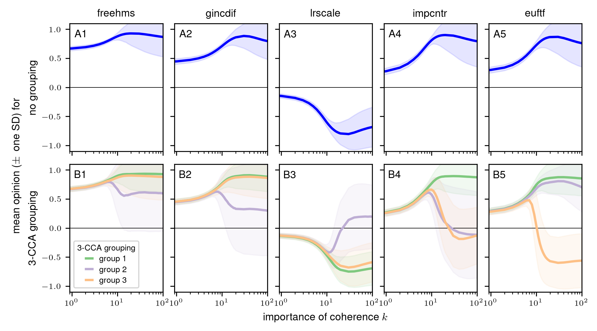

Figure 4 presents a more in-depth analysis of the simulation results as k varies and comparing the 1-group and the 3-group cases. In particular, it shows the mean group beliefs (and the standard deviation) at time *t=200* of the five belief items over different importance of coherence *k* for the experiment without grouping (panels A1 to A5) and with the 3 grouping (panels B1 to B5). In the experiment without grouping, a high importance of coherence, *k=100*, causes the agents to adopt, on average, a strongly negative value on the political orientation (*lrscale*)–implying a left orientation (solid line in Figure 4A3), but there is strong diversity among the agents on this item (coloured area). Similarly, the society converges to quite extreme levels of support for LGBTQI+ rights (Figure 4A1), government involvement in reducing income inequality (4A2), immigration from poorer countries (4A4), and EU integration (4A5). In the experiment with the 3 groups the dynamics are more diverse. For low values of *k*, all groups tend to follow the majority consensus belief. With increasing *k*, this consensus belief moves further away from a moderate centre. If *k* is sufficiently large, there is both between-group and within-group disagreement on most topics and groups. But there are substantial differences in this general pattern between the groups and between the five belief items. For instance, group 1 deviates from the others in terms of immigration (*impcntr*), group 3 on the EU (*euftf*) and group 2 on the other items, but the groups are themselves split. Notably, the threshold of *k* at which groups start to polarise from others and split internally (see, for instance, the green line in Figure 4B1) varies between groups and belief items.

To summarise, the partitioning of individuals into groups with shared cognitive models allowed particular groups to deviate from the others (when the coherence mechanism is strong) leading to various, complex patterns of within- and between-group diversity. These different patterns can be triggered following small increases in the importance of the coherence *k* if the cognitive models differ.

Discussion

Whilst the described work was mostly intended as a proof-of-concept—illustrating an approach that we think will be productive—it does show that: (a) it is possible to move towards a more data-driven approach in terms of specifying aspects of the cognitive models of agents within simulations, (b) that such an approach does significantly change the outcomes in terms of how a diversity of beliefs could be socially preserved whilst those within groups can still remain cohesive, but also (c) that within-group convergence is quite sensitive to the importance of coherence and (d) the potential of this approach to be applied and extended in a number of directions.

Individuals perceive the political world from a subjective viewpoint and often apply subjective cognitive models, which causes them to experience coherence differently and respond in distinct ways to outside influences. This aspect has been rarely studied using (data-driven) models. We have presented such an approach, using CCA to identify groups with shared cognitive models, and comparing simulation results of coherence-seeking individuals for a case in which they share a cognitive model and a case in which they hold distinct cognitive models. In our model, individuals may share a cognitive model even if they hold very distinct beliefs. Two individuals—for example, one with conservative beliefs about migration and economic policies, and one with liberal beliefs on both topics—may both feel coherent, because they share the same cognitive model; a third person with mixed liberal/conservative beliefs may feel coherent only if she holds a different cognitive model that deviates from the conservative–liberal scheme. Ideological pressures may be one possible explanation for the alignment of cognitive models between antagonistic groups, but in this study we are agnostic as to how the individuals have come to share cognitive models. Empirical data on how coherence perception differs within a population, would be useful to validate the model.

In our model, coherence drives two separate kinds of outcome: between-group as well as within-group diversity. This is particularly true if coherence means something different for the individuals because their cognitive models differ. If coherence is unimportant to individuals, a consensus emerges. The more coherence plays a role (so that cognitive models differ), the more diversity manifests within and between groups. Interestingly, we find that the model exhibits non-linear behaviour: a small increase in the importance of coherence can cause a sudden shift from consensus to pronounced diversity, but this threshold varies among different groups.

Our model emphasises the need for agent-based simulation by showing that probabilistic coherence maximisation in a social structure does not necessarily lead to the obvious outcomes (just becoming more extreme in the average direction that a group started with in terms of its belief values). Some results, such as the differential emergence of within-group diversity and between-group diversity, are path-dependent phenomena and thus non-trivial to understand from an equilibrium analysis.

One aspect of our model is that extremeness can increase belief coherence. If two beliefs are correlated, extreme support for both is more coherent than moderate support. We believe—in line with other modelling studies (Dalege et al., 2023)—that this is a reasonable assumption given that more extreme beliefs are less ambiguous and, thus, reinforce consistency. Nevertheless, it is psychologically also plausible that there are individuals that experience strong coherence by remaining neutral or holding moderate beliefs. Whether this is a quality of real-world coherence or due to other mechanisms that favours extremeness of beliefs, remains to be further investigated.

So far, we have treated two types of coherence equivalently—coherence derived from logic relations between beliefs and related opinions or attitudes (e.g. if one does not believe in climate change, one might be less prone to support environmental action, such as becoming vegan) and coherence derived from emergent (social) pressures (e.g. if one is a Democrat, one is more likely to order Latte than black coffee). An obvious next step will be to distinguish these types and study how certain (logic) relations between beliefs, opinions and attitudes are shared among individuals, and how others are subjective properties of a diverse population.

Conclusion

Here we described a more empirically driven approach to specifying the cognitive models of agents in an ABM. This results in different *types* of agents, each of which are based upon a different cognitive model. Of course, in the example instantiation of the general approach shown, we have only taken a modest step towards inferring different ‘cognitive models’ for different groups, represented by the correlation matrix for the group beliefs.

We have shown one way of realising this goal, but freely admit there are many other possible variants. We have shown that this makes a difference—that the outcomes from this, more diverse, approach are significantly different from one where there is a single cognitive model for all. We believe that this direction for developing research is a productive one, and is one that has not been explored.

The difference this approach makes is a matter of degree, the correlation matrix we use could be thought of as a property of the agents interpreted by the coherence framework, but then any algorithm can be encoded as a property (as Turing showed with his Universal Turing Machine in 1933). However, the described approach represents a shift towards inferring the agent cognitive process from data, and thus can be situated within a wider trend towards data-driven rather than theory-driven methods, KIDS vs KISS (Edmonds & Moss 2005).

**Acknowledgments** The collaboration was initiated at the BIGSSS Summer School in Computational Social Science on Social Cohesion 2022 in Groningen (Netherlands) (https://bigssscss.janlo.de/schools-2018-2023/social-cohesion-2022-groningen/) funded by the Volkswagen Foundation. JL and PS acknowledge support from a grant by Deutsche Forschungsgemeinschaft (DFG – German Research Foundation, No. 396901899) for the project “ToRealSim - Towards realistic models of social influence”. BE acknowledges support from a grant by ESRC No. ES/S015159/1 also for ToRealSim. PS acknowledges support from the Deutsche Forschungsgemeinschaft (DFG – German Research Foundation) though the project SEATRAC (project number 423711127) as part of the Priority Programme 1889: Regional Sea Level Change and Society (Sea Level). MB acknowledges the support of the ZumWert project funded by the University of Kassel in their profile building initiative. FK acknowledges the institutional support of the University of West Bohemia in Pilsen.

References

Bandura, A. (2001b). Social Cognitive Theory of Mass Communication, Media Psychology, 3(3), 265-299, https://doi.org/10.1207/S1532785XMEP0303_03

Boutyline, A. (2017). Improving the measurement of shared cultural schemas with correlational class analysis: Theory and method. Sociological Science, 4(15), 353-393. http://doi.org/10.15195/v4.a15

Dalege, J., Galesic, M. and Olsson, H. (2023) Networks of Beliefs: An Integrative Theory of Individual- and Social-Level Belief Dynamics. OSF Preprints. doi: 10.31219/osf.io/368jz

European Social Survey European Research Infrastructure (ESS ERIC). (2021). ESS9 - integrated file, edition 3.1 [Data set]. Sikt - Norwegian Agency for Shared Services in Education and Research. https://doi.org/10.21338/ESS9E03_1

Dean, J. S, and George J. G., (2000) Understanding Anasazi Culture Change Through Agent-Based Modeling. In Timothy A Kohler, and George J Gumerman (eds), Dynamics in Human and Primate Societies: Agent-Based Modeling of Social and Spatial Processes. Oxford Academic, pp. 179–206. https://doi.org/10.1093/oso/9780195131673.003.0013

DellaPosta, D., Shi, Y. & Macy, M. (2015) Why Do Liberals Drink Lattes?, American Journal of Sociology, 120(5), pp. 1473–1511. <https://doi.org/10.1086/681254>.

Edmonds, B. and Moss, S. (2005) From KISS to KIDS – an ‘anti-simplistic’ modelling approach. In P. Davidsson et al. (Eds.): Multi Agent Based Simulation 2004. Springer, Lecture Notes in Artificial Intelligence, 3415:130–144. (http://cfpm.org/cpmrep132.html)

ESS ERIC 2001

Festinger, L. (1957). A theory of cognitive dissonance: Stanford University Press.

Harmon-Jones, E., & Harmon-Jones, C. (2007). Cognitive dissonance theory after 50 years of development. Zeitschrift für Sozialpsychologie, 38(1), 7-16.

Hassan, S., Pavón, J., Antunes, L., & Gilbert, N. (2010). Injecting data into agent-based simulation. In Simulating Interacting Agents and Social Phenomena: The Second World Congress (pp. 177-191). Springer Japan. https://doi.org/10.1007/978-4-431-99781-8_13

Heider, F. (1946). Attitudes and cognitive organization. Journal of Psychology, 21, 107-112.

Heider, F. (1958). The psychology of interpersonal relations. New York, NY: Wiley.

Kennedy, C., Theodoropoulos, G., Sorge, V., Ferrari, E., Lee, P., Skelcher, C. (2007). AIMSS: An Architecture for Data Driven Simulations in the Social Sciences. In: Shi, Y., van Albada, G.D., Dongarra, J., Sloot, P.M.A. (eds) Computational Science – ICCS 2007. ICCS 2007. Lecture Notes in Computer Science, vol 4487. Springer, Berlin, Heidelberg. https://doi.org/10.1007/978-3-540-72584-8_144

Newman, M. E. J. (2006). Modularity and community structure in networks. Proceedings of the National Academy of Sciences, 103(23), 8577–8582. https://doi.org/10.1073/pnas.0601602103

Thagard, P. (2000). Coherence in Thought and Action. The MIT Press. https://doi.org/10.7551/mitpress/1900.001.0001

Turing, A. M., (1936) On computable numbers, with an application to the Entscheidungsproblem. Proc. of the London Mathematical Society, 2 42:230-265.

Watts, D.J. and Strogatz, S.H. (1998) ‘Collective dynamics of “small-world” networks’, Nature, 393(6684), pp. 440–442. Available at: https://doi.org/10.1038/30918

Wilensky, U. (1999). NetLogo. http://ccl.northwestern.edu/netlogo/. Center for Connected Learning and Computer-Based Modeling, Northwestern University. Evanston, IL.